***Amendment to Invoice Item and Invoice Module***

***IVA*** is charged at the different rate based on the product. Same invoice may include items that have rates varying between 0 - 16%. Not all the items are charged at the same rate. As it appears on the example bellow, some are charged at 12% while other -0%:

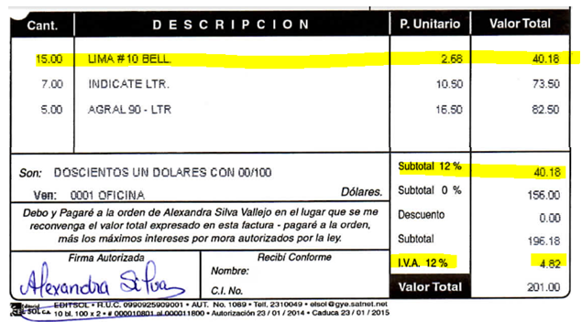

There are two possible ways to approach the solution:

***Option 1***: ***Additional table to be introduced to let user select applicable rate***

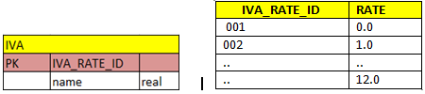

To reflect his change, Invoice Item table needs additional IVA_ID fields (Foreign Key to IVA table).

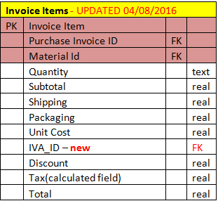

User should only select IVA rate that applies and system calculated IVA value that should match same one on the invoice.

***Changes to UI:***

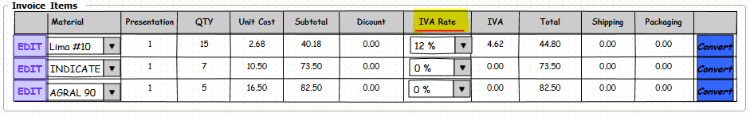

***Option 2***: ***Let user enter IVA rate as appears on the invoice system calculates the IVA value based on user’s input. IVA rate field than would be a required field with default value of 0.0% and IVA rate of $0.00. System calculates and updates IVA value based on the user input. This approach has greater risk of human error compare to pre-set IVA rate dropdown list.***

|  |  |  |  |
| --- | --- | --- | --- |
| **Invoice Items** - UPDATED 04/08/2016 | | | |
| PK | Invoice Item |  |  |
|  | Purchase Invoice ID | FK |  |
|  | Material Id | FK |  |
|  | Quantity |  | text |
|  | Subtotal |  | real |
|  | Shipping |  | real |
|  | Packaging |  | real |
|  | Unit Cost |  | real |
|  | IVA_RATE |  | real |
|  | Discount |  | real |
|  | Tax(calculated field) |  | real |
|  | Total |  | real |

